

l

**By: Code Ctrl**

**814000758 - Valini Deonarine**

**814001227 - Dylan Deyal**

**814002931 - Christian John**

**814000442 - Jeremy Naipaul**

**814004746 - Renado Paria**

**--------------------------------------------------------------------------------------------------**

**INFO 3490 - PROJECT**

**Department of Computing and Information Technology**

**Lecturer: Ms Cynthia Cudjoe**

**Tutor: Mr Shiva Ramoudith**

**Date Submitted: 12 April, 2017**

**Abstract**

What if you were to be told that a Trinidadian athlete was able to break and set a new world record in some sporting field just this year, February 2017? Would you believe this information? Probably not, however it is true. Local athlete Rondel Hunte broke a world record for powerlifting while participating at a national competition. The event and achievement however did not gain much media attention with only a single article ever being published about his journey and accomplishments.

Sport continues to be an ever growing market with fans that are passionate and supportive beyond other fan bases. Local athletes from all countries who wish to participate in sport must first have the support of their country as well as the finances to do so. Today’s media in individual countries mostly however popularize sports mainly from an international and regional level without shining a light on the upcoming athletes and teams who are working towards being able to represent their country. Without the necessary media attention that will help to open up investment and sponsorship opportunities for them, local athletes are left disadvantaged. Many athletes are thusly unable to meet their fullest potential.

The application Sport Junkie will seek to bridge the gap between today’s media and these local athletes as well as local sporting events and news. The application will be available from both a web and mobile platform and will focus on delivering the most recent local sporting news to users.

It would allow users to view articles, filter them by a specific sport and even add them to a ‘favorites’ list, keep up with the latest scores for local events and also allow authorized authors to post articles immediately to the main application.

Sport Junkie hopes to take advantage of the fact that no application like it exists in the Caribbean and also reach the largest possible market by being accessible on any device capable of connecting to the internet.

**Table of Contents**

1.0 Introduction and Background…………………………………………………………………………….**1**

1.1 Introduction

1.2 Problem Statement

1.3 Project Description

1.4 Project Objectives

1.5 Project Stakeholders

1.6 Project Deliverables

1.7 Feasibility Assessment

1.7.1 Economic Analysis

1.7.2 Technical Analysis

1.7.3 Operational Analysis

1.8 Team Plan

1.8.1 Team Composition

1.8.2 Methodology

2.0 User and System Requirements…………………………………………………………………………….**6**

2.1 Scope

2.2 Definitions, Acronym and Abbreviations

2.3 User Characteristics

2.3.1 Readers/ Viewers

2.3.2 Authors

2.4 Requirements

2.4.1 Functional Requirements

2.4.2 Non-functional Requirements

2.5 Data Requirements

2.5.1 User

2.5.2 Article

2.6 Design Constraints

3.0 System Architecture………………………………………………………………………………….………….**15**

3.1 Scope

3.2 Architectural Design

3.3 Software used to implement Architecture

3.4 Database Architecture

3.5 System Operation

4.0 System Design Artifacts………………………………………………………………………………………..**16**

4.1 Data Interface

4.2 User Interface

4.3 Class Diagram

4.4 Component Diagram

50. Modifications…………………………………………………………………………………………………..……**-**

6.0 Implementation Framework and Details……………………………………………………………….**17**

7.0 Testing…………………………………………………………….…………………………………………………….**18**

7.1 Test Plan

7.1.1 Purpose of test plan

7.1.2 Description of testing

7.2 Unit Test cases

7.2.1 Sign up

7.2.2 Log in

7.2.3 Dashboard

7.2.4 Featured Page

7.2.5 Latest Page

7.2.6 Categories

7.2.7 View articles

7.2.8 Managing articles

7.2.9 Delete Account

7.210 Log out

7.3 Stress and Performance Testing

7.4 Reliability Testing

8.0 Tools and Component Reuse……………………………………………………………………………….**27**

9.0 Business Aspects………………………………………………………………………………………………...**28**

10.0 Individual Contributions…………………………………………………………………………………….**29**

11.0 Conclusions and Lessons Learnt…………………………………………………………………………**30**

12.0 References…………………………………………………………………………………………………………**31**

13.0 Appendices………………………………………………………………………………………………………..**32**

Appendix 1 – Use Cases

Appendix 2 - Database architecture diagram

Appendix 3 – Sequence Diagrams

Appendix 4 – Dataflow Diagrams

Appendix 5 – Screens

Appendix 6 – Class Diagrams

Appendix 7 – Web application component diagram

Appendix 8 – Usability Testing User Questionnaire

# **1. Introduction and Background**

## **1.1** **Introduction**

Sports continues to be one of the most popular hobbies of people around the globe and serves as entertainment worldwide, drumming up business and profits in all countries, including Trinidad and Tobago. With the world of sports being so vast, news of local and regional sports sometimes gets lost in the worldwide coverage.

## **1.2** **Problem Statement**

The sporting sector in the Caribbean is quite underdeveloped. An attributing factor to this is the lack of a medium for the broadcasting of local sport news and events and local team achievements and experiences. Sources for local sport news are limited to the newspapers and local sport television and radio news segments. Most of what is publicized relates to sporting on a national and regional level but does not identify the smaller groups within the countries who are partaking and excelling. As a result, most of these groups and teams go unnoticed.

Code Ctrl aims to solve these issues by providing a service that focuses on these local teams and local sporting events to help them garner public attention and investment. With this goal in mind, the application Sport Junkie would be developed.

## **1.3** **Project Description**

Sport Junkie will be both a web based and mobile application and its primary purpose is to deliver sport related information to fans of any sport in one convenient package. Authors will write on the latest sport news and push the articles to the application making them available to any user with a verified account. It will feature news for, but not limited to, football, cricket, swimming and varying marital arts. Where applicable, the sport will be sub divided into their respective leagues or categories thus allowing the user a greater chance to find what they’re looking for.

It should be expandable such that in the future, it can be accommodating to international sport news without needing an overhaul or much reconstruction.

## **1.4** **Project Objectives**

• To close the gap between sport fans and sport information.

• Promote sporting events.

• Provide event, sport and team information all in one convenient package.

• Garner attention for local sport teams and competitors.

• Popularize and promote sport throughout the Caribbean region thus driving development of the sector.

## **1.5** **Project Stakeholders**

*User Stakeholders*

|  |  |
| --- | --- |
| **User** | **Need** |
| **General Public/ Readers** | Simple to navigate, aesthetically pleasing, accurate and real time information |
| **Administration** | The application should function as expected. |
| **Authors** | The application should be simple to use and allow articles to be posted and updated without problem. |

*Non-User Stakeholders*

|  |  |
| --- | --- |
| **User** | **Need** |
| **Investors** | The application should meet the requirements agreed upon and function as expected. It should be usable and meet customer demands. It should be publicly acceptable and meet the goals it were intended for. |
| **Sport Teams/ managers** | Information appearing in any article in the application should be truthful and accurately reflect the current state of the local teams, players and their achievements. |
| **Sporting Event Coordinators** | Event information should be accurate and easy to understand. |

## **1.6** **Project Deliverables**

1. Mobile application: An application that will run on all android devices.

2. Web Application: A main website that has the same operations as the android application as well as a dashboard that will be used to publish information to the main mobile site/mobile app.

3. Associated Documentation: Documentation that outlines the details of the project. These documents will only be shared with the appropriate stakeholders.

**1.7** **Feasibility Assessment**

**1.7.1 Economic Analysis**

Given that no other application of its kind exists, the potential for capturing the market stands great. Like any project, expenses include labour, hardware, software, a contingency fund, etc. However, the benefits far outweigh the general costs as the application is targeted to one of the largest groups of any population, i.e. sport fans, and can therefore turn over a profit within the first few years.

|  |  |  |
| --- | --- | --- |
| **Item** | **Cost (TTD)** | **Benefit** |
| **Mobile Testing device -** Use of a simulator or already owned mobile device | - | Results in less errors in final deliverable |
| **Workstations -** Team members already had devices to work on and the free computer facilities at the university were utilized. | - | Facilitates development and the ability to work 24/7. |
| **Firebase Additional Storage** | 175/ month | Facilitates expansion of the application in order to meet the goals of the application. |
| Given that the costs are not extensive, the benefits gained are greater. | | |

### **1.7.2 Technical Analysis**

Project risks include:

* Lack of funds for investment into software and additional storage.
* Limited human resources on the project team
* Time constraint limits research, development and testing

These risks do impact the project however delivering the application given the limited resources within the time frame is still realistic. Considering that there was also no high initial investment cost, the project, as such, is one of low risk.

### **1.7.3 Operational Analysis**

It solves the issue of information inaccessibility of sport related news throughout the Caribbean and can thus promote various sports and facilitate development of the sector in general.

As the first of its kind and targeted towards one of the largest groups of persons of any population, the application would serve as an attractive platform for other companies wishing to advertise their business, especially those involved in the sport sector.

## **1.8** **Team Plan**

### **1.8.1 Team Composition**

The table below shows the makeup of the team along with respective roles:

|  |  |
| --- | --- |
| **Team Member** | **Role** |
| Christian John | Web Engineer |
| Dylan Deyal | Web Engineer |
| Jeremy Naipaul | Web Application User Interface Designer, Document Officer |
| Renado Paria | Android Developer |
| Valini Deonarine | Project Manager, User Interface designer |

### **1.8.2 Methodology**

The project team will follow the steps of a typical agile development cycle. As one phase is completed, the findings will be presented to the client for their incremental approval. Changes will be incorporated as feedback from the user is received and as such the final deliverable may vary the original scope defined or the requirements initially set out.

# 

# **2. User and System Requirements**

## **2.1 Scope**

This section will outline the agreed upon features which the final deliverable of the project should consist of. It defines the application requirements and their constraints, as well as the necessary data and user characteristics.

## **2.2 Definitions, Acronym and Abbreviations**

Listed in the table below are terms that are used throughout the requirements section and what they refer to in the real world.

|  |  |
| --- | --- |
| **Term** | **Refers to...** |
| **User** | Any general user of the system. |
| **Reader** | Specifically a user with no author privileges |
| **Author** | A user who can access the dashboard |
| **OS** | Mobile Operating System |
| **Featured Page** | The page on which the most popular articles appear. |
| **Latest Page** | The page on which the newest articles are displayed. |
| **Dashboard** | A feature accessible only on the web application which facilitates the uploading and editing of articles by ONLY authors. |
| **Main Site** | The application on the web platform. |
| **Home Screen** | The application on the mobile platform. |
| **Landing Page** | Signup/ Login page on both the web and mobile platforms. |

## **2.3 User Characteristics**

Users of the application are grouped into two main categories:

### **2.3.1 Readers/ Viewers**

* + These users’ access is limited to the main site of the application which can be done either via the web or mobile app.
  + Readers can view articles on any of the available pages however they may not edit the content.
  + Articles can be “hearted” and so added to their favorites.
  + Readers may also choose to select to view articles by a particular sport category.

**2.3.2 Authors**

* + Authors can access both the dashboard and main site.
  + Via the dashboard, authors are able to write their own articles and post them to the application so they can be viewed on the main site.
  + The dashboard also provides them with a current list of all articles which they have authored.
  + Authors also have privileges to edit any article which they have already written.
  + These author privileges however do not extend to allow articles to be deleted.

All users are required to sign up and create accounts in order to have access to the application.

## **2.4 Requirements**

### **2.4.1 Functional Requirements**

Use Case Diagrams for these requirements can be seen in Appendix 1.

#### **2.4.1.1 Sign Up**

Sport Junkie should allow users to Sign up. Only readers are allowed to sign up either with the credentials of an existing Google account or create their own within the application. Authors will have accounts already created for them. This function is implemented on both the web and mobile platform and is necessary as users cannot access the main site or home screen without being logged in.

#### **2.4.1.2 Login**

The system shall allow users to login. Both the main site and dashboard require users to login in. For the main site, readers and authors are prompted to the input an email address and password which are validated by Firebase authentication, and once validated, gain access. The dashboard however is only accessible on the web platform with author specific credentials.

#### **2.4.1.3 Session Handling**

The system shall provide session handling on both the mobile and web platform.

On mobile, users would first be prompted to login before accessing the application content. If already logged in, the page which the user had last accessed should still be held in memory and as such, be reloaded. In the event that the page was no longer held in memory, the application will load the featured page.

On the web, both authors and readers are prompted at the landing page to sign in before accessing the dashboard or main site. If already logged in, users can access any link within the site, however should they log out, before accessing any other page within the site, users will be redirected to the landing page to login once more.

#### **2.4.1.4 Dashboard**

The system shall have a dashboard. The dashboard will be accessible exclusively to authors and facilitate the posting of new articles and editing of existing ones. The dashboard will be personalized to the specific author by displaying all the articles which they have created; most recent article first.

#### **2.4.1.5 Featured Page**

Sport Junkie shall have a ‘Featured’ Page. This page shall provide users with a list display of articles based on popularity, i.e. articles with the most views will be displayed on this screen.

#### **2.4.1.6 Latest Page**

Sport Junkie shall have a ’Latest’ page. This page should display the newest articles on the site beginning with the most recent article.

#### **2.4.1.7 Category**

The application shall provide a Category page which will display the various sport categories by which users are allowed to browse. For each category available to choose from, users will be able to view a featured and trending page specific to that sport.

#### **2.4.1.8 View Article**

Sport Junkie will allow users to view articles. Readers can view articles on both the main site on the web and the home screen on the mobile app. From the list of articles displayed on any of the pages of the application, once selected, the full object for that specific will be loaded so users can view.

It is important to note that via the dashboard, authors also can specifically view any article which they have created.

#### **2.4.1.9 Manage Articles**

The application shall allow authors to manage their articles. Via the dashboard, authors have the capability to create new articles and post them to the application. They would also be allowed to select any article which they have previously posted or drafted (not yet posted) and edit it in order to update it or make it final to be posted.

#### **2.4.1.10 Delete Account**

The application shall allow users to delete their accounts. At any time, a user of the application can choose to delete his account, at which point he will be prompted to confirm this action. Once confirmed, the user’s account data will be removed from the application database.

#### **2.4.1.11 Media Storage**

Sport Junkie shall utilize Firebase storage for media storage in order to keep gallery images, article header photographs and profile pictures.

#### **2.4.1.12 Logout**

The Application shall allow users to log out thus suspending their account from being active. This implies that the user account will no longer be an authenticated user of the system and will no longer have access to the application’s content. The user will need to login once more and have this account data validated before gaining access.

### **2.4.2 Non-functional Requirements**

#### **2.4.2.1 Application Start-up Time**

Given a stable Internet connection, Sport Junkie, on both the web and mobile platforms, should start up within 1 to 2 seconds. If the Internet speed is below average, the start-up time will be slower.

#### **2.4.2 Data Load Time**

Given a stable Internet connection, Sport Junkie, on both the web and mobile platforms, should be able to retrieve all data and perform all functions specific to that screen within 1 to 2 seconds. If the Internet speed is below average, the load time will be slower.

#### **2.4.2.5 Real Time Database**

The database is updated in real time in order to ensure that the application content is reflective of the most current news in the sports world.

#### **2.4.2.6 Database Security**

On both the web and mobile platforms, users can access and read data once authenticated. This is done via the application interface and holds true for users with and without author privileges.

On the web platform specifically, the dashboard is only accessible to authenticated users with author privileges. A whitelist of valid user IDs is created and will determine who these users are.

#### **2.4.2.7 User Account Authentication**

User accounts are validated by Firebase or Google.

When a user registers for the application using an email and password, other than Google sign in credentials, a unique ID is created for that account by the Firebase authentication system which is used to identify the account. This is used to check that the account and passwords match in order to grant the user access to the application.

Users who register using Google account credentials, would be authenticated by the process specific to Google. Once authenticated by Google, the user is logged in.

#### **2.4.2.8 User Credentials Validation**

Email addresses are required to meet a specific format, e.g. example@eg.com. Invalid email addressed will not be accepted.

Passwords must be at least 8 characters. Passwords of a shorter length will be rejected and the user will be prompted to reenter a password.

First names and last names are required to be longer than 3 characters in length else would be considered invalid and therefore would not be accepted.

#### **2.4.2.9 Password Security**

The Firebase Authentication system stores all passwords entered by users in a file that is only accessible to the system for authentication checks. This file cannot be read or written to.

#### **2.4.2.10 Compatibility**

Sport Junkie should be designed such that it can be run on Android versions 4.x to the current.

The architectural design of the application should be compatible with all current web browsers and their most recent versions.

#### **2.4.2.11 Screen Size Responsiveness**

The application’s display, for both the web and mobile, will be responsive and adaptable to various screen sizes.

#### **2.4.2.12 Article Upload Time**

Assuming the average size of an article and given a stable internet connection, an article is expected to be able to be uploaded in 50 seconds or less. Articles of above average size may take longer.

#### **2.4.2.13 Article Push**

Specific to the web platform, after an article is uploaded via the dashboard, it must appear in the application within 5 seconds or less. It should appear in the list of articles written by the specific author and it must also appear on the main site on the Latest page.

#### **2.4.2.14 Page Security**

On the web, a service called AuthGuard was developed and implemented. Its purpose is to ensure that pages are not accessible via URLs without having previously provided valid login credentials. In the event that any user is not currently logged in, the service should prevent access to the page and redirect the user to login before proceeding.

On the mobile platform, in order to prevent users from accessing screens, other than the login/ sign up page, within the application without having logged in, a redirect was developed using android/java code to detect authentication state changes within each activity.

### **2.5 Data Requirements**

The requirements for the data that is required for the application are listed and described below. These requirements are necessary for creation of a relevant and efficient database and to be able to map the application’s inputs and outputs.

### **2.5.1 User**

Listed below are the data requirements for a user (Author and viewer) entity:

|  |  |
| --- | --- |
| **Name** | **Description** |
| **UID** | This is a string that will uniquely identify every user with a SportJunkie account. This is generated automatically by the firebase database. |
| **First Name** | This is a string that stores the user’s first name. |
| **Last Name** | This is a string that stores the user’s last name |
| **Email Address** | This is a string that stores the user’s email address. This is used to sign in to the account after account is created |
| **profilePicURL** | This url references the user profile picture that is stored in firebase online storage. The url is created when a user uploads a profile picture during the sign up process |
| **isAuthor** | A Boolean value that helps differentiate between viewers and authors. During sign up it is set to false as default. |

### **2.5.2 Article**

Listed below are the requirements for an article entity:

|  |  |
| --- | --- |
| **Name** | **Description** |
| **ArticleID** | This is a string that will uniquely identify every article published by the SportJunkie dashboard. This is generated automatically by the firebase database. |
| **Title** | This string stores the article title. |
| **Subtitle** | This string stores a secondary article title. |
| **Article Data** | This refers to the article contents. |
| **Category** | This string stores the category the article belongs to |
| **authorUID** | This is a reference to the user id of the user who posted the article. |
| **authorFirstName** | This is a reference to the user first name of the user who posted the article. |
| **authorLastName** | This is a reference to the user first name of the user who posted the article. |
| **TimeAndDateCreated** | This is the time and date the article was initially created and published. |
| **LastUpdated** | The time the article was last updated by an author. |
| **URLtoImage** | The url to the image stored via firebase online storage that is used for article main image. |
| **Number of clicks** | An integer used to store the number of times an article was accessed. It is used by the application to sort by popularity |
| **Gallery of images** | A list of urls to images stored via firebase online storage that is used for article galleries. |

## **2.6 Design Constraints**

* Storage cost - Firebase provides limited storage and requires payment for additional space.
* Standards or codes relating to design - The Angular 2 Framework had to be followed making design and structuring more complex.
* Available resources - not very many online or text resources relating to the programming language or frameworks were available for use.
* Mobile OS Compatibility - The mobile version of the application was designed to only run on a specific range of Android OS versions.
* Time - time constraints limit the scope of the project and there is a difference between what is proposed to what is realistically possible.
  + Development - some features had to be excluded as the time limit was not enough for these features to be developed and be functional.
  + Testing - test plans had to be developed with the time constraint in mind. Typically, testing is an ongoing process, however many testing procedures had to condensed or simplified in order to further the development process.
  + Research and learning - with limited time, new skills and techniques could not all be learned in time to benefit the project. In the same manner, the use of new technologies and software could not be learned in time to add efficacy to the project or simplify tasks.
* Knowledge - the skill set of each team member and the combined knowledge was still limited and many skills had to be learnt in order to complete the project.
  + Documentation - many segments of documents that were necessary to produce required research as some of these analytical reports were never done before.
  + Development - in order to program the application to meet all the agreed upon requirements, many new frameworks, technologies and programming languages had to be learned.

# **3. System Architecture**

**3.1 Scope**

This section gives a high level overview of all the system architecture and underlying technologies that were used in the development of Sport Junkie. It pertains to the components on the both the web and mobile platform.

**3.2 Architectural Design**

The application is split into two platforms which are mobile and web. These two platforms have various methods of design patterns with which to follow, but an Object oriented approach was selected for the mobile application and a component based approach was used for the web application.

The object oriented approach (OOP) was selected because it is easier to maintain and improve upon. It also allows for individuals who did not create the code to understand it much easier than other conventional methodologies. Additionally it allows for creation of objects and classes which further simplifies how entities within the program interact with each other. Finally, inheritance, the process by which objects can acquire the properties of objects of another class, is also a trait of OOP which was used throughout the development of the application

The component based approach used for the web application was selected because it helped make a modular application, which just like the OOP approach, was easier to maintain and improve upon.

**3.3 Database Architecture**

A Diagram of the database architecture can be seen in appendix 2.

The firebase real time database stores data in JSON objects and places them in a hierarchical format. At the top of the hierarchy is the Firebase database which is connected to by two main nodes, “Users” and “Articles” which are stored. In these two nodes or branches, several smaller ‘children’ nodes exist. This data is nested in order to show its relation.

The “Users” node contains data such as first name and last name which relates to viewers and authors in the SportJunkie Application.

The “Articles” node contains the data for articles that have been posted to the application from the dashboard.

The hierarchy is almost flat because when data is fetched at a location in the database, all children nodes are fetched as well. Additionally, when a user is granted read or write access at a node in the database, all data under that node is accessible by the user.

**3.4 System Operation**

The sequence diagram found in appendix 3 illustrates a typical usage of the sport junkie system and how various objects interact with each other in the system. When the user accesses the application on either the mobile or web platforms, they are prompted to log in using their account credentials, or create an account using their email address. When they successfully log in they can then view and read articles as well as favorite them. On completing their usage of the application they can log out thus terminating their session.

# **4. System Design Artifacts**

**4.1 Data Interface**

In order to show how and when the database would be utilized by the application to store data, data flow diagrams were created, illustrated in the appendix 4. These diagrams show the data that is entered into the system by external entities and then stored to the database. There is a context level diagram that shows the main inflows and outflows of the system as well as a level one diagram. This diagram breaks down the major inflows and out flows as well as the general process into smaller processes, further illustrating how data is handled by the application.

## **4.2 User Interface**

There are three main user interfaces across various platforms for the SportJunkie application, the mobile main platform, the web browser main platform application and the web browser dashboard.

Low level prototype screenshots and descriptions can be seen in appendix 5.

## **4.3 Class Diagram**

The class diagram represents the structure of the code used in the mobile application. It shows the relationships of existing objects and how they interact with each other as defined by the developers.

The class diagram can be found at appendix 6.

## **4.4 Component Diagram**

The component diagram shows how the web application was built. It shows how each component is laid out and how they interact with each other.

The diagram shows the breakdown of the Angular2 web application by components. The main application component is supported by three shared components; sign in for the dashboard, sign in for the main site and sign up. The sign up components are supported by the homepage and dashboard components. These two components have children components, with homepage’s child component being view-article and the Dashboard component having List-Article, Add-Article, View-Article and Edit-Article. Each component in the application has its own CSS and html file to fill content as well as various typescript files for dependency injections as well as routing. An example of this would be the View-Article component having view-article.component.css, view-article.component.html, view-article.component.ts and finally view-article.component.spec.css.

The component diagram can be found at appendix 7.

**6.0 Implementation framework and details**

**Software used**

* Firebase Real Time Database- this software development kit provides users with intuitive APIs to help them develop databases, create authentication systems and even collect analytics. It was especially chosen to be used in the backend for its simplification of real-time processing that allows the delivery of notifications and updates to the application, on both web and mobile, as quickly as possible.
* Ninjamock - design software that facilitates the creation of screens and reports for platforms including Web, iOS, Android and Windows phone. It has been used to create many low fidelity prototypes that have been used to influence the eventual design of the application on both platforms.
* Communication Software - Firebase: BAAS - Backend as a service
* Programming Languages:
  + Mobile -
    - Java: this programming language is used in order to create android applications for mobile phones and tablets. Android was selected as it has the largest amount of users within Trinidad and Tobago as well as the Caribbean.
  + Web -
    - Angular 2: this technology was used for the front end of the web application because it is used for responsive front end design and creation of single page applications using data binding and html injections.
    - HTML: this is used in the development of all web applications as it creates electronic documents called pages which are displayed to the user.
    - CSS and Bootstrap: these are used to aid in building a responsive design for web applications quicker than from scratch as the components are ready made and easy to apply
    - JQuery: this library was used to make up for the shortcomings of angular in certain situations.
* CASE tools -
  + - Google Docs: used for drafting documentation allowing multiple members to edit simultaneously
    - GitHub: this was used for application version control.
    - Google Drawings, Microsoft Visio, Draw.io: used for diagram creation
* Development Tools:
  + - Android Studio, Intellij Pro IDE: used for development of the mobile and web applications respectively
    - Angularcli, NPM: used for launching the angular application initially for testing

**7 Testing**

**7.1 Test Plan**

**7.1.1 PURPOSE OF TEST PLAN**

This plan will fully document the testing done to the sport junkie application as well as its results in order to effectively refine the application’s operations and discover and correct any problems encountered. The test plan will target the mobile application, main web application and the dashboard.

**The types of testing done:**

Unit and component testing

Stress and Performance testing

Reliability testing: Usability testing which also tests integration, performance and reliability

**7.1.2 Description of testing**

After requirements were gathered and analysed, prototypes for the application were created in order to ensure the requirements were realistic and could be delivered in a stable and safe product within the timeframe allotted. These prototypes were created such that their basic structures would remain the same throughout the development process but at the same time would allow functionality to be easily added and removed without having to redesign certain operations at each milestone. After testing of early prototypes against requirements described during the gathering process, it was found that none were too complex or unrealistic and as such, features were not removed from the later prototypes and the final application. Because of the very detailed requirements, the both web and mobile applications were created very similar and as such allowed for almost the same testing approaches to be applied to both applications.

During the design phase, the firebase database was created and functionality to connect and read/write to the database were added to the prototypes that were being developed during that period. The structure of the data stored and how to store it was revised constantly in order for mobile and web applications to use less processing power to fetch and post efficiently. The tests used helped to find ways to optimize fetch and post request as well as reduce the storage and memory required to keep the real time database fully functional and accurate.

While the development process went on, as each prototype was created, the developers of both the web and mobile applications made sure to test each unit created with each other as a form of integration testing before adding it. Additionally, various undocumented stress tests such as observations of memory utilization were performed on the applications as further functionality was added on. When the system was finalized, test cases were created and used to formally test each unit and components, a final stress test was performed and a formal usability test was created. Usability testing was used in order to test the performance under stress and reliability of the applications using a live environment. These usability tests were done with the final prototypes and targeted all aspects of the applications’ features. These tests were important as they were to be used as confirmation that all user requirements were satisfied as well as to verify the application’s stability under heavy usage.

**7.2 Unit Test cases**

**7.2.1 Sign up**

|  |  |  |  |  |
| --- | --- | --- | --- | --- |
| Test ID | Scenario | Steps | Expected Results | Actual Results |
| 1.1 | Users accesses site and attempts to sign up using valid information( email,password, first name and last name). | User enters valid information and clicks submit button. | User is now able to sign in. | Account is created for user and can now log in at the home page |
| 1.1 | Users accesses site and attempts to sign up using invalid information( email,password, first name and last name). | User enters valid information and clicks submit button. | An account is not created for the user. | The user cannot submit invalid information so an account is not created for the user |

### **7.2.2 Log in**

|  |  |  |  |  |
| --- | --- | --- | --- | --- |
| Test ID | Scenario | Steps | Expected Results | Actual Results |
| 2.1 | Users accesses site and attempts to sign in using valid credentials ( email,password) or by google sign in | User enters valid credentials and clicks sign in button or uses google sign in button | Homepage is loaded and displayed to the user | User session is created and Homepage is displayed to the user |
| 2.1 | Users accesses site and attempts to sign in using invalid credentials or uses google sign in without a google account | User enters invalid credentials and clicks sign in button or uses google sign in without a google account | Application does not accept credentials and remains on the Landing page. | Application does not accept credentials and remains on the landing page, but a login error is displayed to the user |

### **7.2.3 Dashboard**

|  |  |  |  |  |
| --- | --- | --- | --- | --- |
| Test ID | Scenario | Steps | Expected Results | Actual Results |
| 3.1 | Author attempting to log into Dashboard. | Author accesses dashboard landing page and enters credentials | Dashboard homepage is displayed. | Author session is created and Dashboard homepage is displayed. Author operations and list of articles published are displayed |
| 3.2 | Non-Author attempting to log into Dashboard | Non-Author accesses dashboard landing page and enters credentials | Application does not accept credentials and remains on the Landing page. | Application does not accept credentials and remains on the Landing page but displays credential error message. |

**7.2.4 Featured Page**

|  |  |  |  |  |
| --- | --- | --- | --- | --- |
| Test ID | Scenario | Steps | Expected Results | Actual Results |
| 4.1 | User successfully logging in | User logs in | Featured page is displayed. | Up to date Featured page is displayed to user. |
| 4.2 | User selecting Featured tab on any page | User selects Featured on the navbar(web) or drawer screen(mobile) | Featured page is displayed | Page redirects to the up to date Featured page |
| 4.3 | User entering Featured page url into browser | User enters page url in browser. | Featured Page is displayed | Featured page is displayed |

### **7.2.5 Latest Page**

|  |  |  |  |  |
| --- | --- | --- | --- | --- |
| Test ID | Scenario | Steps | Expected Results | Actual Results |
| 5.1 | User entering Latest page url into browser | User enters page url in browser. | Latest Page is displayed | Login page is displayed |
| 5.2 | User selecting Latest tab on any page | User selects Latest on the navbar(web) or drawer screen(mobile) | Latest Page is displayed | Page redirects to the up to date Latest page |

**7.2.6 Categories**

|  |  |  |  |  |
| --- | --- | --- | --- | --- |
| Test ID | Scenario | Steps | Expected Results | Actual Results |
| 6.1 | User selecting sports category | User selects desired category from the category section | Desired category articles displayed | Featured articles in that particular category are displayed |

### **7.2.7 View articles**

|  |  |  |  |  |
| --- | --- | --- | --- | --- |
| Test ID | Scenario | Steps | Expected Results | Actual Results |
| 7.1 | Viewing articles | 1. User navigates to site with relevant articles  2. User selects desired article from list of articles | Article is displayed | Article contents are displayed along with a gallery and some suggestions of similar articles |

**7.2.8 Managing articles**

|  |  |  |  |  |
| --- | --- | --- | --- | --- |
| Test ID | Scenario | Steps | Expected Results | Actual Results |
| 8.1 | Publishing an article | 1. Log in to dashboard  2. Select add article option  3. Create article by adding relevant content(eg. Details and images)  4. Click submit button | Article is published | Article is published to the application and is displayed in a list along with previously published articles. |
| 8.1 | Editing an article | 1. Log into dashboard  2. Select article  3.Click edit article option  3. edit article by adding/changing content(eg. Details and images)  4. Click submit button | Article changes are saved and article is republished | Article changes are saved and article is republished. The article is still displayed in a list with other previously published articles. |
| 8.2 | Viewing articles | 1. Log into dashboard  2. Author selects desired article from list of articles  3.click view button | Article is displayed | Article contents are displayed |

**7.2.9 Delete Account**

|  |  |  |  |  |
| --- | --- | --- | --- | --- |
| Test ID | Scenario | Steps | Expected Results | Actual Results |
| 9.1 | User wants to delete their account | 1.Navigate to profile page  2.Click remove account  3. Confirm action | Account is removed | Account is removed and user is redirected to landing page. |

### **7.210 Log out**

|  |  |  |  |  |
| --- | --- | --- | --- | --- |
| Test ID | Scenario | Steps | Expected Results | Actual Results |
| 9.1 | User wants to log out | Click log out button on any page | User is logged out. | User session is terminated, logging them out and redirecting them to the landing page |

## **7.3 Stress and Performance Testing**

This type of testing was done by the developers as the application were being developed. Using the prototypes created they monitored how much resources the applications used and how they operated over prolonged periods of time. The results of these tests helped the developers when they began optimizing the application before the final release.

The web application was monitored using the web browser console and network tabs . The console showed what data was being passed to the application and the network tab showed how much of the network was being utilized as the application was being used. Additionally, windows task manager was used to see how much memory the application was taking up in order to run efficiently over a period of three hours.

The mobile application utilized android studio’s emulation console in order to see how much memory the application was using on a typical mobile device. This was key because if the application took too much memory then the device would begin to slow down and become unresponsive. The developers took the recorded information and used it in aiding with memory use reduction and optimization. The screenshot below shows how the data was displayed to the developers.

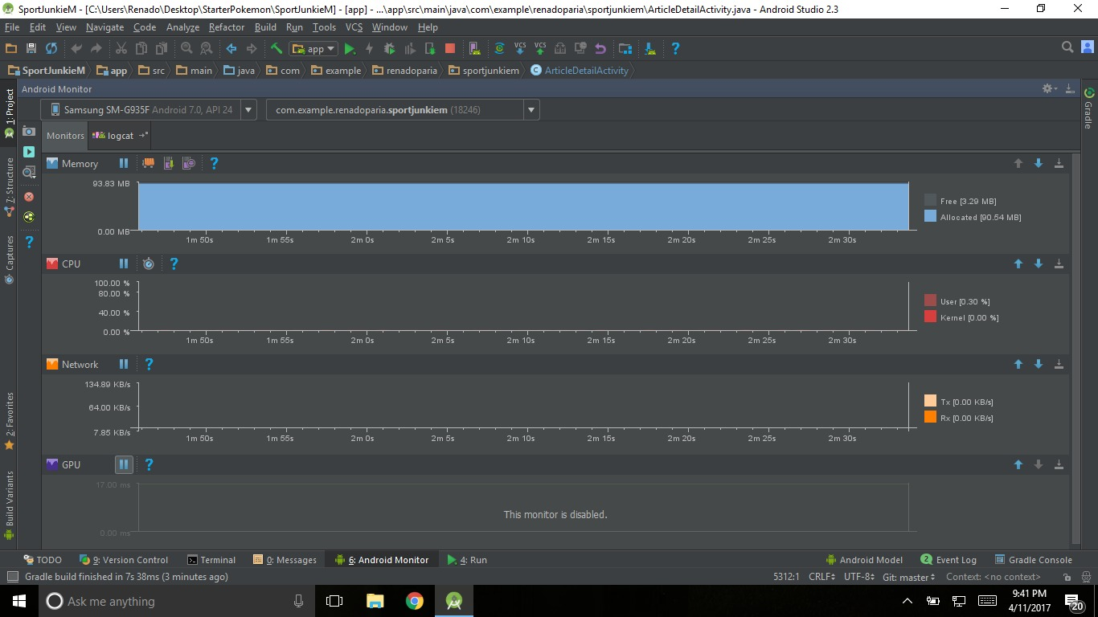

After the final application was completed, one more stress test was performed on the final prototypes to make sure they were optimized properly before they were submitted for performance testing by users.

## **7.4 Reliability Testing**

**USABILITY TESTING**

Usability testing took place after both the web and mobile applications were completed and unit and component testing took place. This meant that the developers had a high level of confidence in the application and felt that the best way to test stress and performance was in a live environment.

**TASK LIST**

1. Create an account and record the feedback given after successful creation e.g.( the X page opens).
2. Sign in and record which page is displayed initially.
3. Open any article and record the first sentence as well as the title and sub title of the article.
4. Add the second football article on the featured page and the first cricket article on the latest page to favourites. Record the following information about these articles: article title, author and date uploaded.
5. Change User profile picture and record feedback after successful change.
6. Delete any one article from favourites and record the new list of favourite articles.

**USER FEEDBACK FORM**

A copy of this form can be found at appendix 10.

**ANALYSIS OF USABILITY TESTING**

Candidates for testing were selected and reduced to five individuals, two of these individuals being IT special students, the other two from humanities and education faculty and one from the medical faculty of MT. Hope Medical School. Each user was made to complete the various tasks without any assistance from peers or from external sources such as the internet while being observed by the development team.

On starting testing, the first two tasks were completed quickly by all users because of the simplistic nature of the tasks. The third task was completed successfully by all users, however two users took longer than others when using the mobile application. The fourth task was completed correctly by all users within acceptable time without any errors. The fifth task and sixth tasks also proved to be simple as all users completed them without errors or complaints.

**ANALYSIS OF USER FEEDBACK**

The feedback after the usability testing indicated to developers that the lack of navigational errors proved that the application was user friendly, allowing users to pick up on the many visual and textual aids to successfully complete tasks given. The majority of the users had no problem utilizing the applications because of the simplistic design and how logical it was structured.

There were little to no problems navigating through the site as over 80% of user agreed that the menu was available and function on every page they visited, further allowing for easy use. The majority of the users also agreed that the application’s fonts were easy to read and the application were clearly labelled and free from distracting information.

Finally, the users were asked if there were any noticeable problems with the application after prolonged use and none of them indicated that there were any issues. This showed that the application was reliable and could handle usage over prolonged periods by multiple users at the same time.

**8.0 TOOLS AND COMPONENT REUSE**

Since the sportjunkie application is a new idea and application there were no predecessor applications to draw from and reuse components. Instead the application had to be built by firstly creating its own components and then making sure those components were re-applicable to the application.

**Web application**

The web application that was built using angular framework allowed for creating components that could be used as views or containers for different purposes through the application

Additionally, bootstrap components that existed previously were also used in order to develop the application. The components provided the developers with html code in a set layout that would speed up the development process which mean it reused in the structure of the application as well as inserted into views via html injections done by angular

Authguard functions utilizing firebase were also reused between the dashboard and main web application in order to reduce the amount of unique authentication functions that interacted with the firebase real time database.

In some cases where angular could not do a certain task, methods from the jquery library were used to parse some data from json format in order to get tokens for authentication.

**Mobile application**

In the mobile application, because OOP was used in the development of the application there was a high reuse level of objects, classes and adapters in order to reduce the size of the application and optimize the utilization of the application. Inheritance also allowed for certain stock classes within the java language to be used by the developers along with new and improved methods.

The importation of android libraries also helped speed up the development process and simplified many tasks for the developer as certain operation code did not have to be written from the ground up. These libraries imported were mostly used in order for interaction with firebase database, authentication and to make the application more responsive. Additionally, an image library was used in order to assist in scaling images for different screen resolutions. Without these libraries available, the developer would have had to build significantly more foundation objects or parts before creating a working application.

The both applications were created in a modular way so that most of the application would be reusable for further improvements or additions in the future.

**9.0** **Business Aspects**

Sport Junkie is the first sports app being developed within the Caribbean that focusses solely on local talent and events. The sports sector is a multibillion dollar industry with a fan base that would continue to grow exponentially. Sport Junkie will be targeted towards this community, as well as local athletes, teams and event coordinators.

The app which is available on both the web and mobile platforms currently faces no IP or Patent issues. Most, if not all the information featured in the application would be considered as public information.

Companies and teams looking to invest in the application can feel confident that their ads and news will have the ability to reach one of the largest audiences in the shortest amount of time given that the application is updated in real time.

Novel features such as the scoreboard and ability to save and favorite articles to a personal profile from within the application set SportJunkie apart from its competition. No such features are implemented by online local newspapers or blog sites. Additionally, as compared to traditional media and online media sources, there is no set upload or ‘news time’. Any information pushed the application by verified authors will be updated to the main site in real time thus providing users with latest information as it becomes available. With traditional media, users would have to wait until the preset ‘news time’ in order to get updated information.

There are many athletes throughout Trinidad and Tobago and the Caribbean with great potential in the sporting sector and we should give them the attention that they require and deserve. By creating a buzz within the sporting community and bridging the division between these small athletes and investors, SportJunkie can help to drive growth within the sector as it continues to popularize stories that are currently not being mentioned in the media.

**10.0 CONTRIBUTIONS**

Valini Deonarine: all documentation, project planning as the project manager, requirements gathering, worked with Jeremy on design specification. Also assisted in making key design decisions with regard to the web application’s main app as a user interface designer.

Dylan Deyal: Web platform application dashboard, backend design which entailed database design and user authentication for the web application.

Christian John: Created the main web application for general users, assisted in the requirements gathering as well as the database design for the application.

Jeremy Naipaul: all documentation, requirements gathering, diagrams utilized in the design documents as well as use case diagrams, conducted testing, and assisted Renado Paria with user interface design for the mobile application.

Renado Paria:Android application Development and assisting with project documentation in the requirements gathering phase as well as testing phase.

# 

# **11.0 CONCLUSION**

Over the course of 13 weeks, a group of 5 individuals have been able to come together and work to carry a project from start through finish. The project experience for CodeCtrl has been both a fun and learning experience. Along the way, we learnt many new technical skills as well as real world experience.

Lessons Learnt:

* Implementing and manipulating Firebase
* Android Development
* Time management skills
* Contingency planning
* Angular 2
* Proper presentation preparation and skills
* Conducting an elevator pitch
* Stress testing for applications

# 

**12.0 References**

[**https://standards.ieee.org/**](https://standards.ieee.org/)

[**https://firebase.google.com/docs/**](https://firebase.google.com/docs/)

[**https://angular.io/**](https://angular.io/)

[**https://stackoverflow.com/**](https://stackoverflow.com/)

[**https://developer.android.com/index.html**](https://developer.android.com/index.html)

**Appendices**

## **Appendix 1 – Use Cases**

Sign up

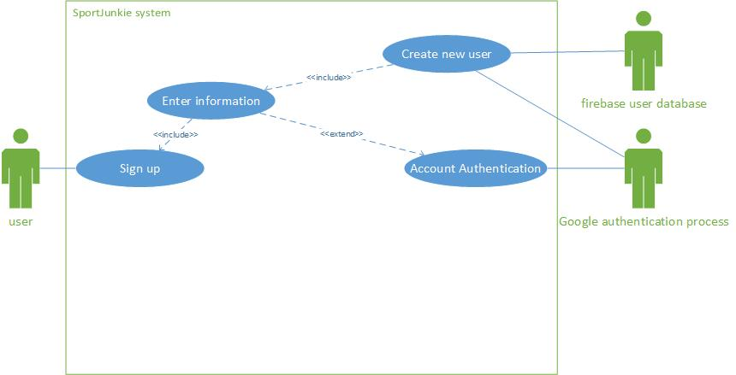

Log in

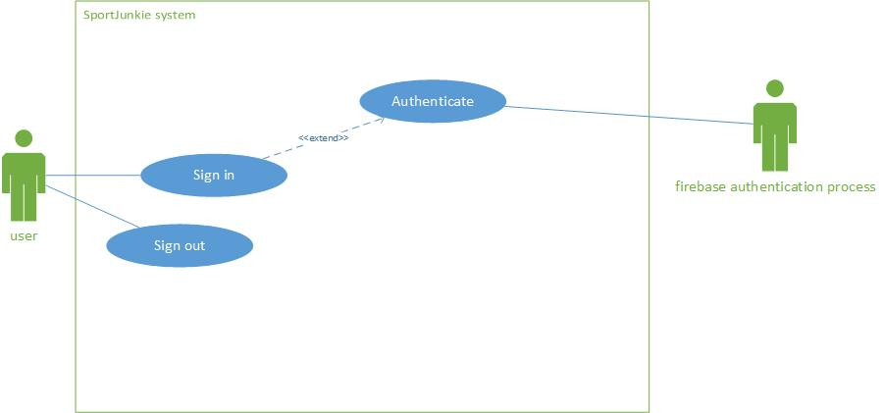

Session handling

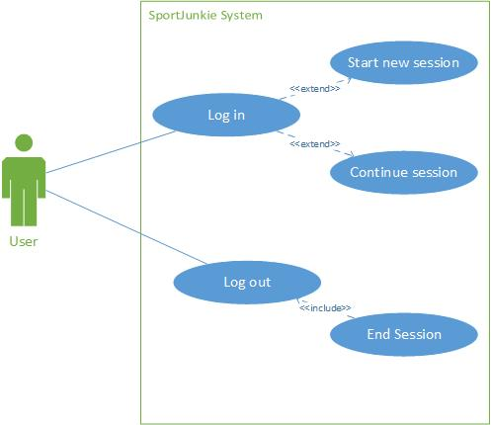

Featured page

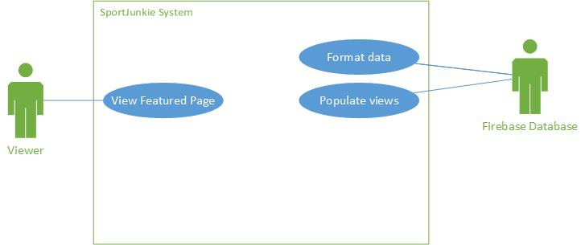

Latest page

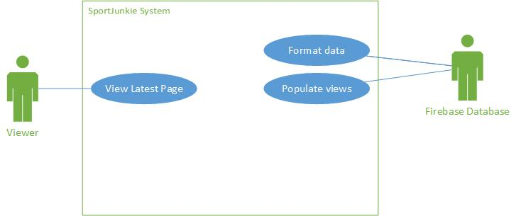

Category

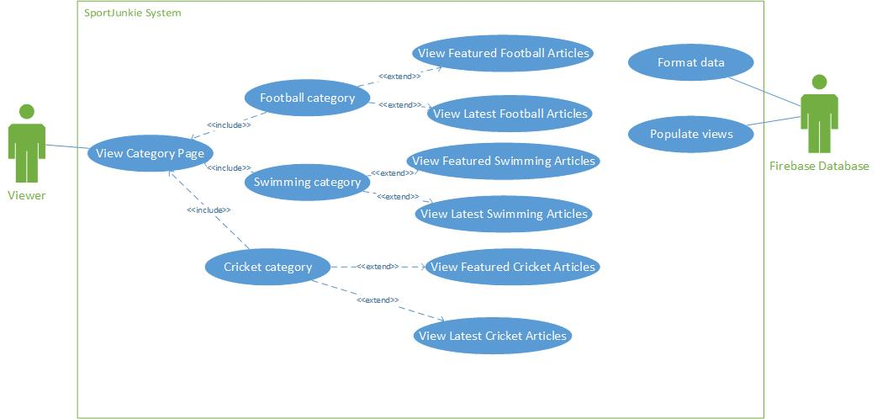

View Article

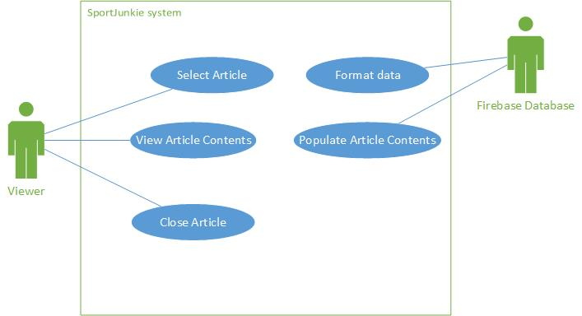

Manage articles

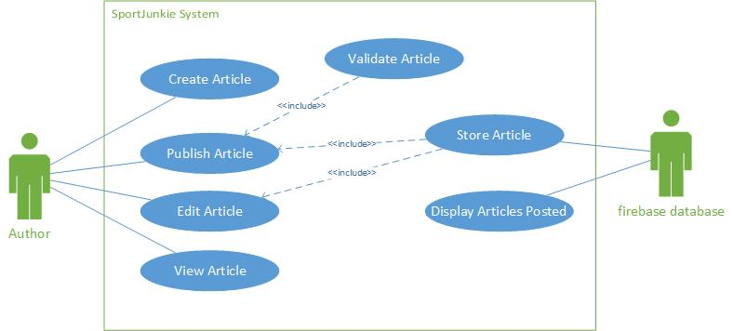

Delete account

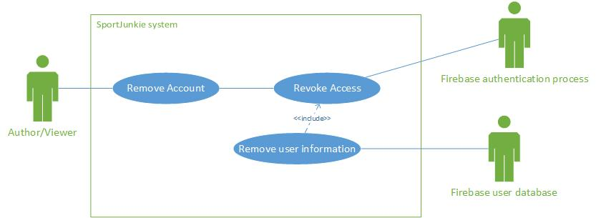

Media storage

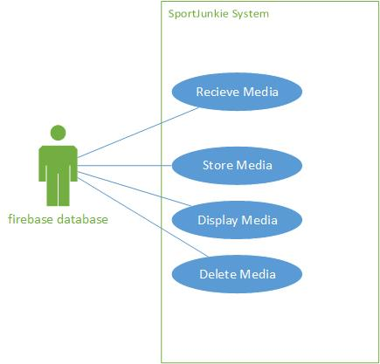

Logout

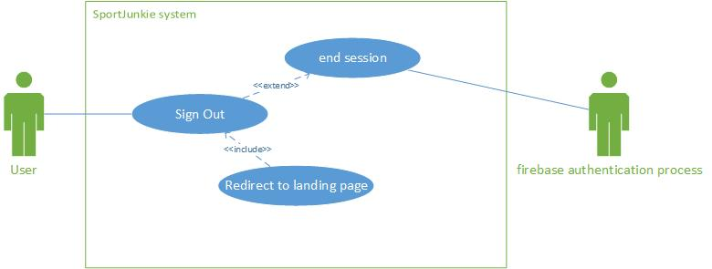

## **Appendix 2**

Database architecture diagram

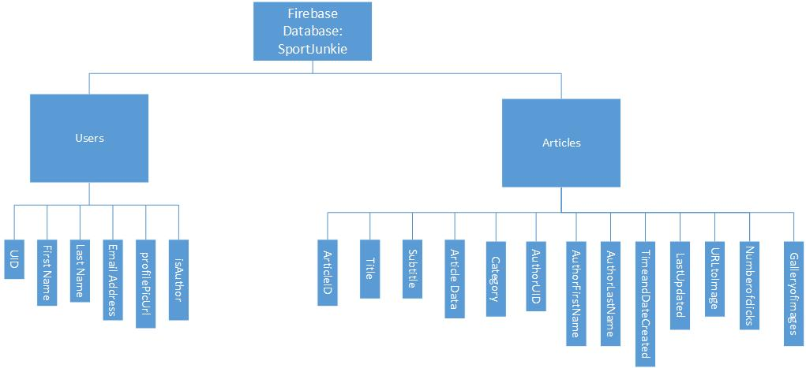

## 

## **Appendix 3**

The Figure below describes the typical sequence of events that will occur when the SportJunkie Application is utilized.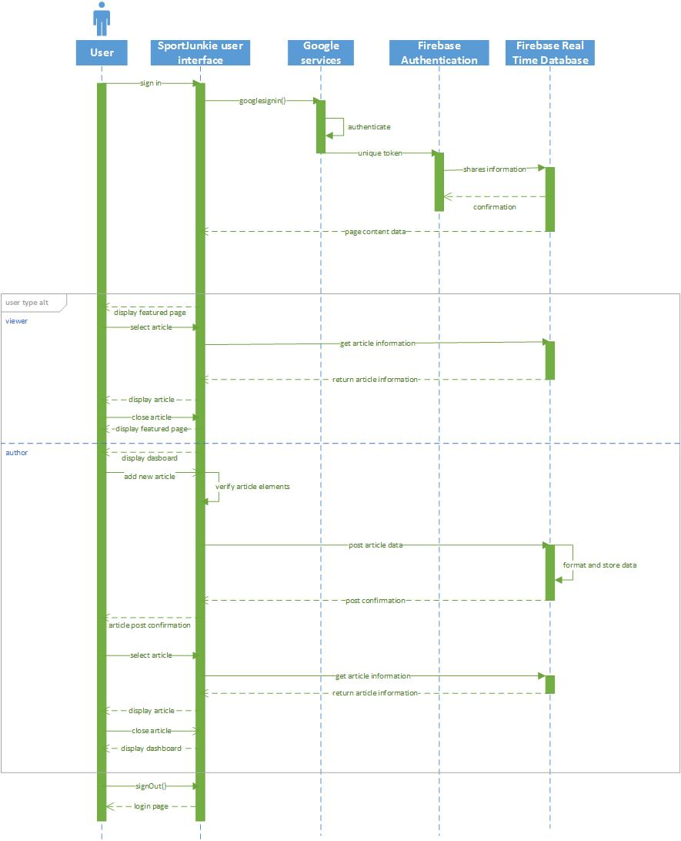

## **Appendix 4**

Database dataflow diagrams

Context level diagram:

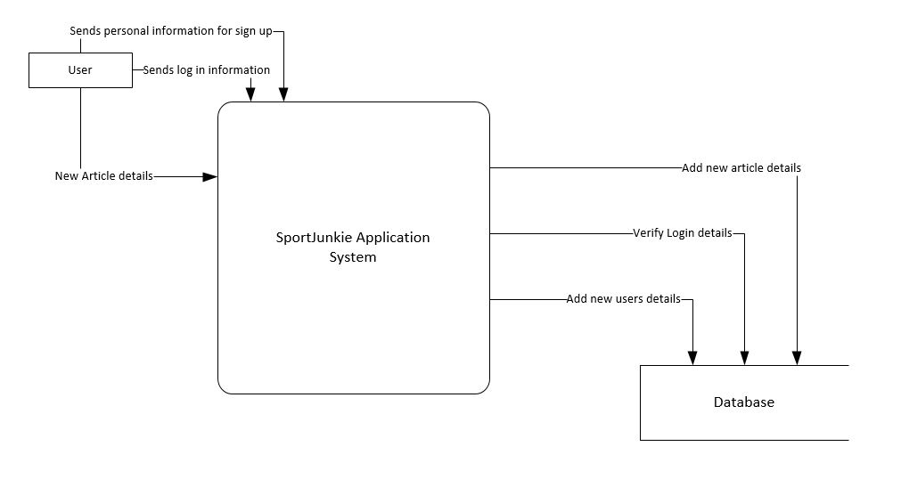

Level one diagram:

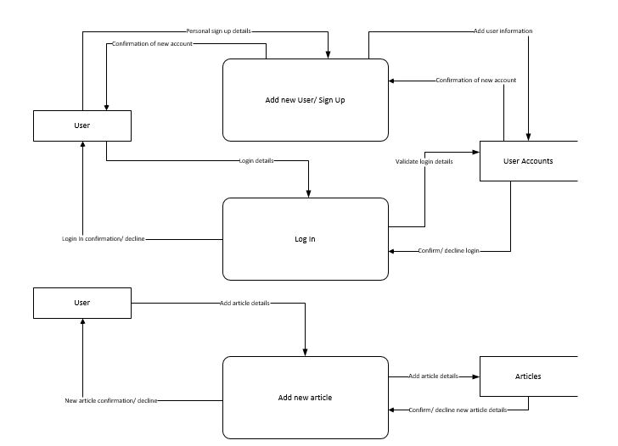

**Appendix 5 – Screens**

The screenshots below illustrate the user interface for the main mobile and web applications respectively.

Mobile

*Home Screen*

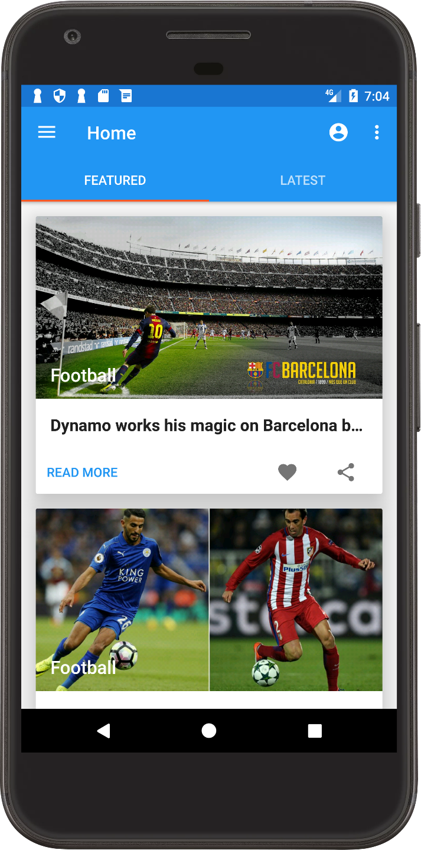

*Navigation*

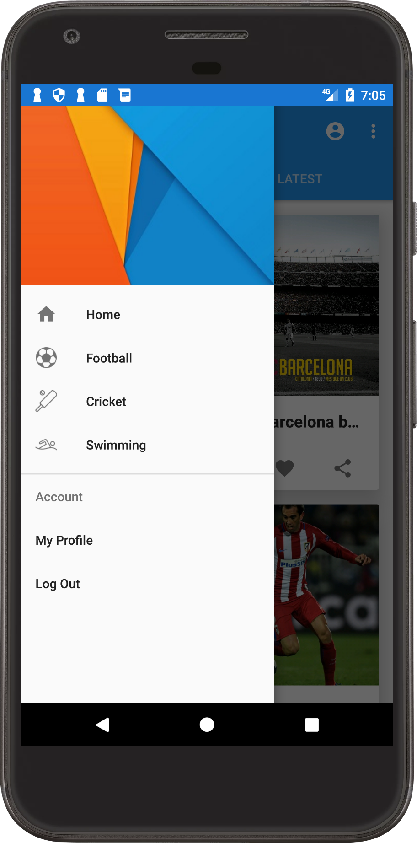

*View Article*

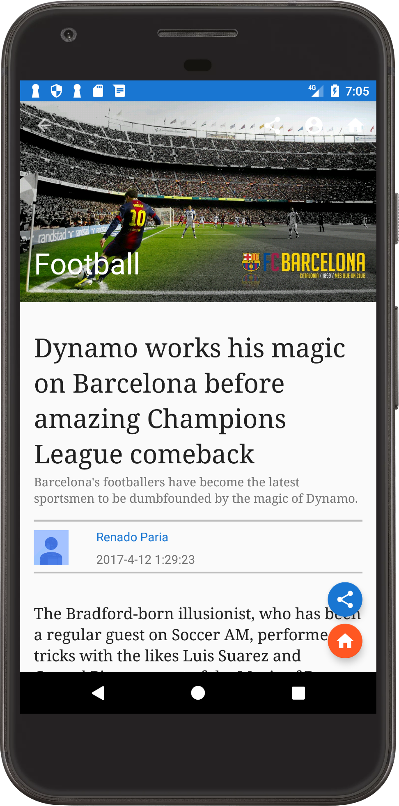

*Gallery of images within article*

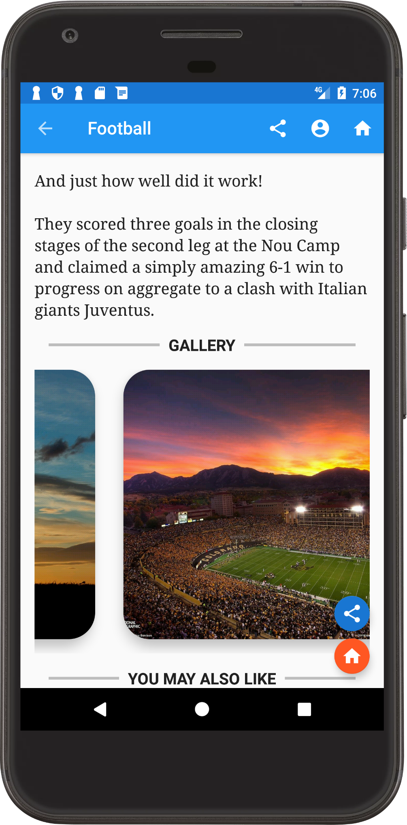

*Other listed articles by the author of the article currently being viewed*

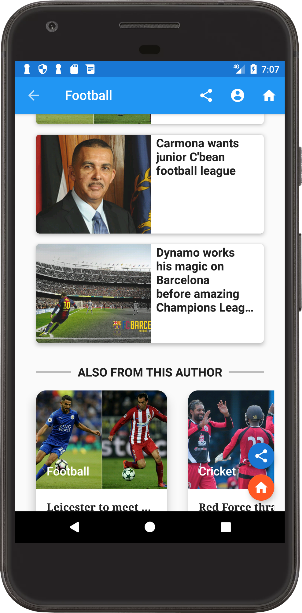

Web

***Home***

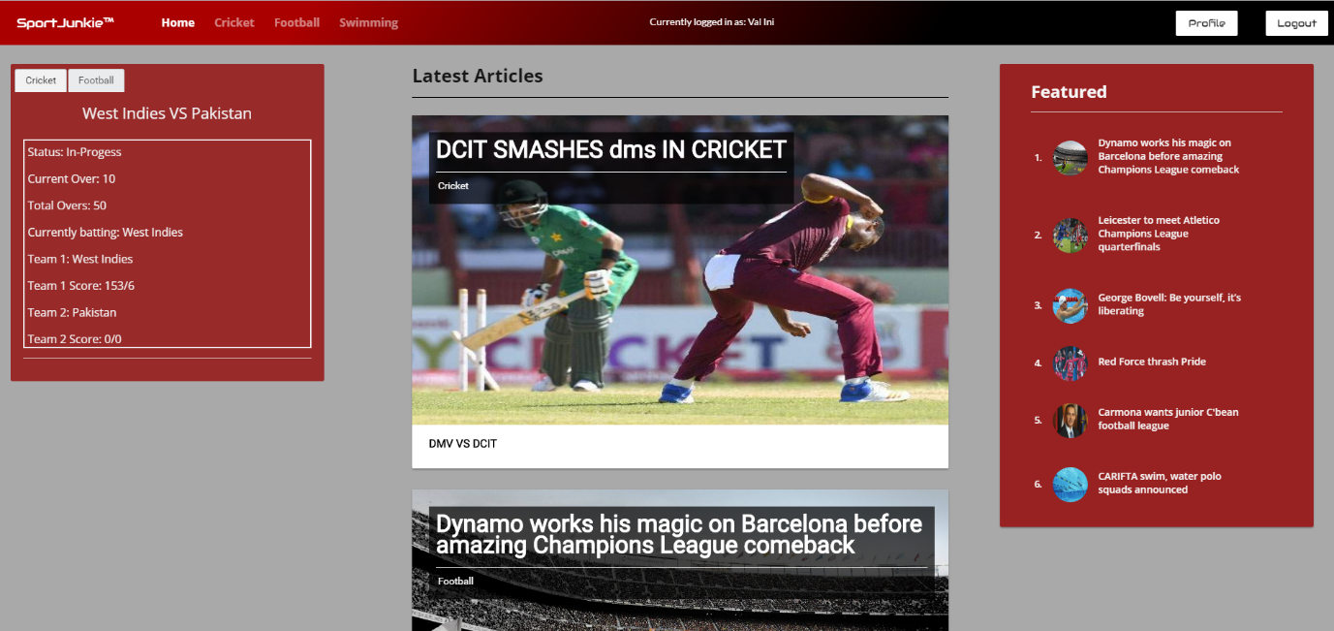

On this screen, the user is able to see the most recent articles uploaded to the site, the most popular articles to the right and a scoreboard of games for various categories of sport.

***View Profile***

From this screen, the user can see their account details, statistics based on the articles they have viewed as well as a list of favorite articles.

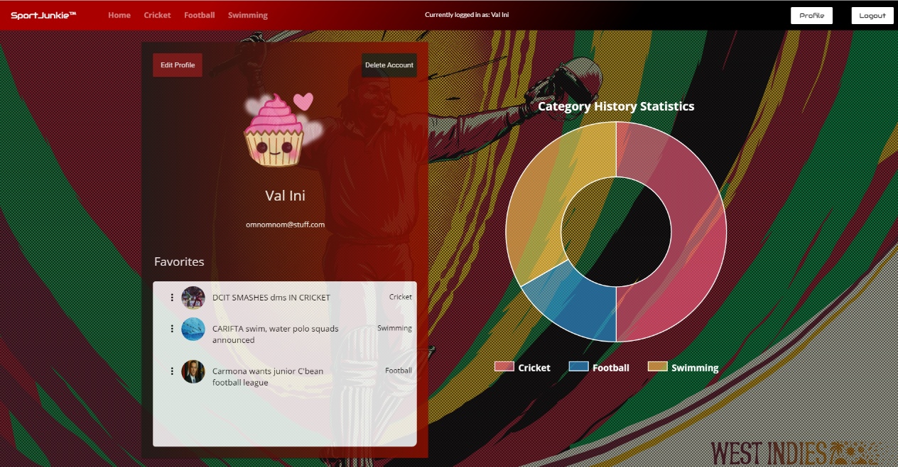

***View Article***

The screen below shows what it would look like if the user were to select to view any article. Below the article title, the category of sport that the article is specific to is listed along with the thumbnail image attached to the article. Then is other article details such as the date it was uploaded and the author and finally is the article body followed by a gallery of related images.

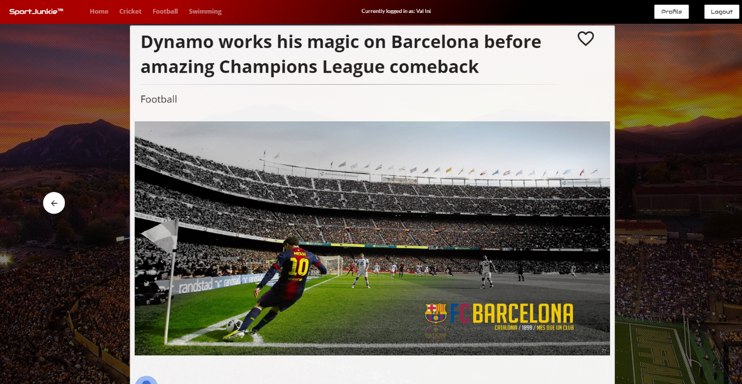

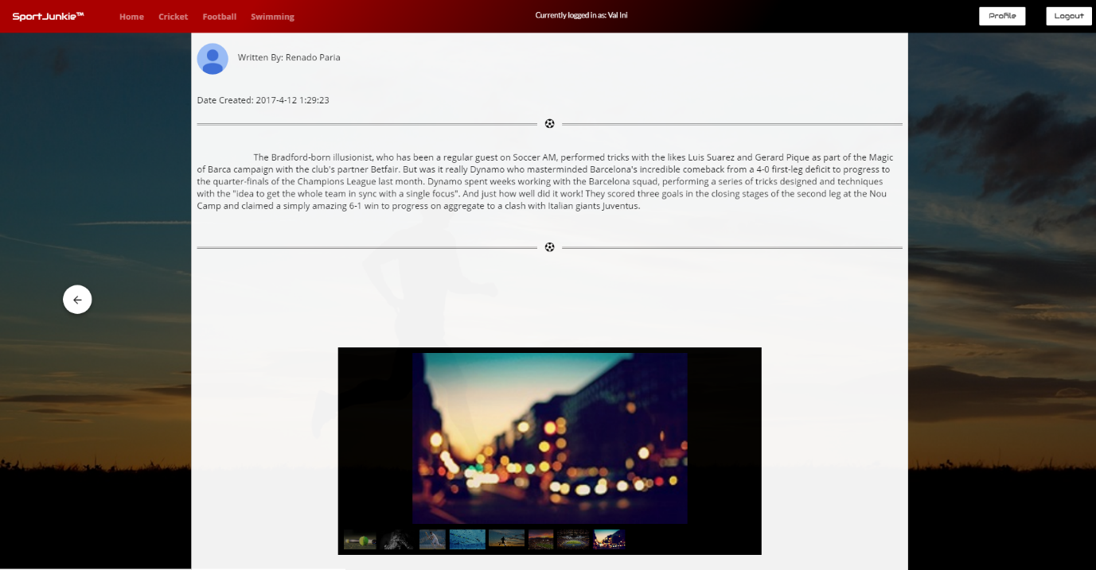

***View articles by Category***

The following screens shows what would be presented to the user should they select to view articles by a specific sport category.

It is important to note that the scoreboard to the left, like the list of latest and featured articles, all filter to display only those details relevant to that particular sport category.

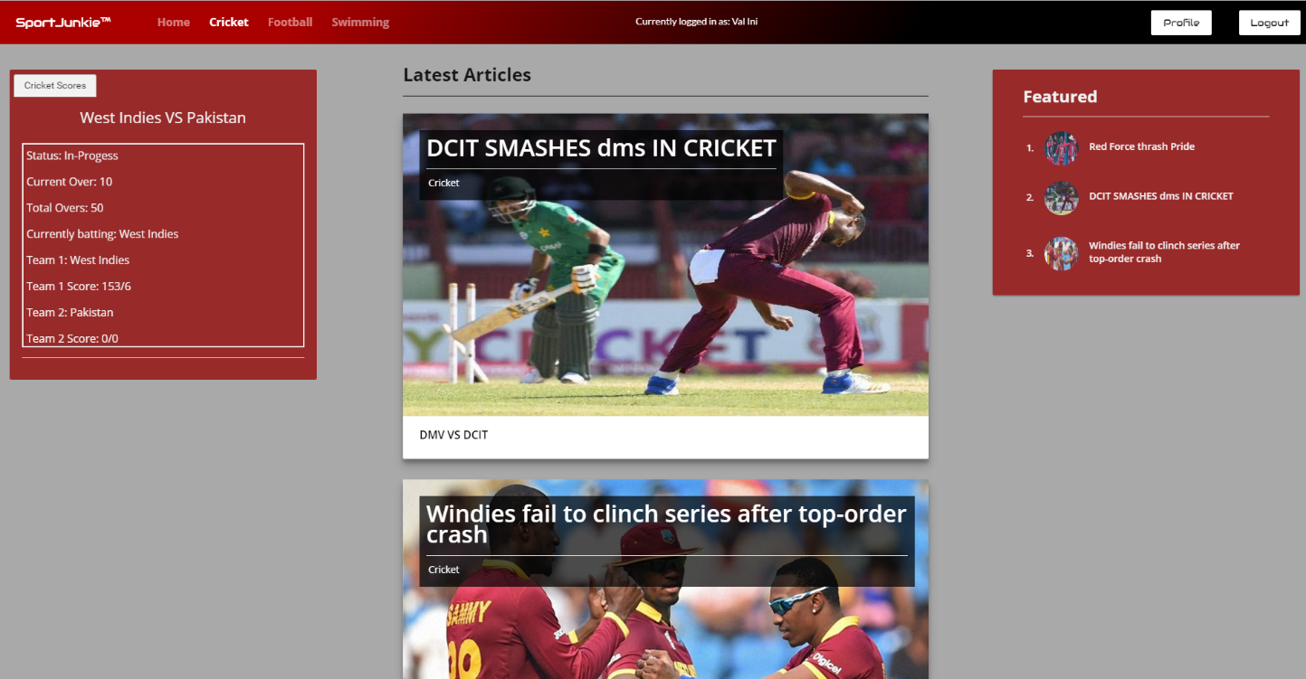

**Appendix 6 – Class Diagrams**

Overall Class Diagram

The figure below depicts the mobile application class diagram overview.

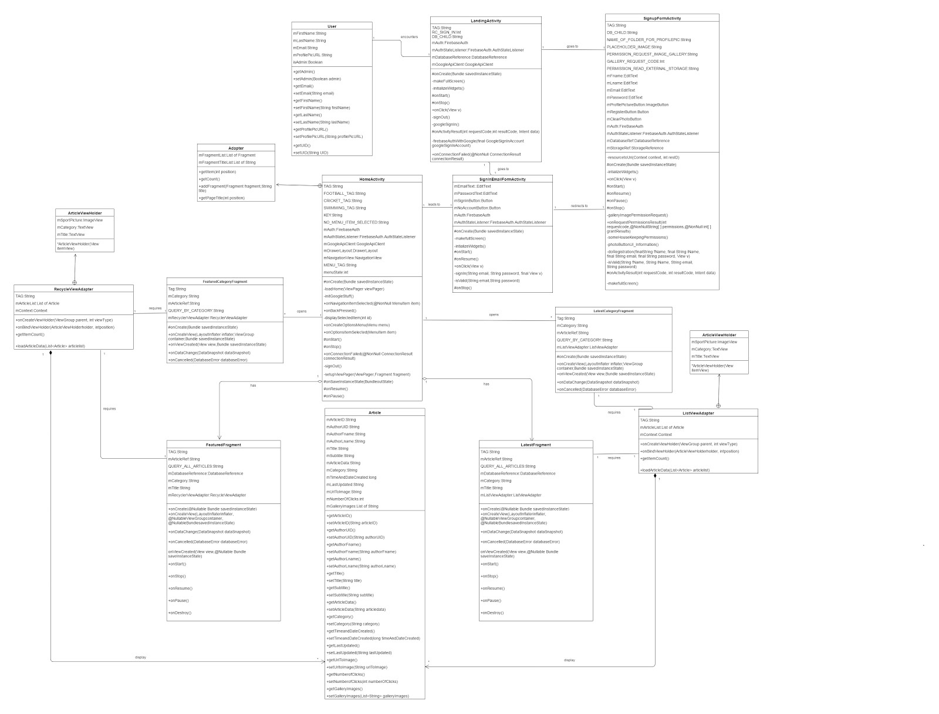

The diagrams below illustrates segments of the class diagram originally displayed above.

**The diagrams use the HomeActivity class as the central hub for presenting the diagram in segments.

**Segment 1**

This Segment of the class diagram shows how user, LandingActivity, SignupFormActivity, SigninEmailFormActivity as well as the HomeActivity and Adapter Classes interact with each other. These classes relate to the user, the initial landing page as well as signing up and signing it to the application and viewing the home page.

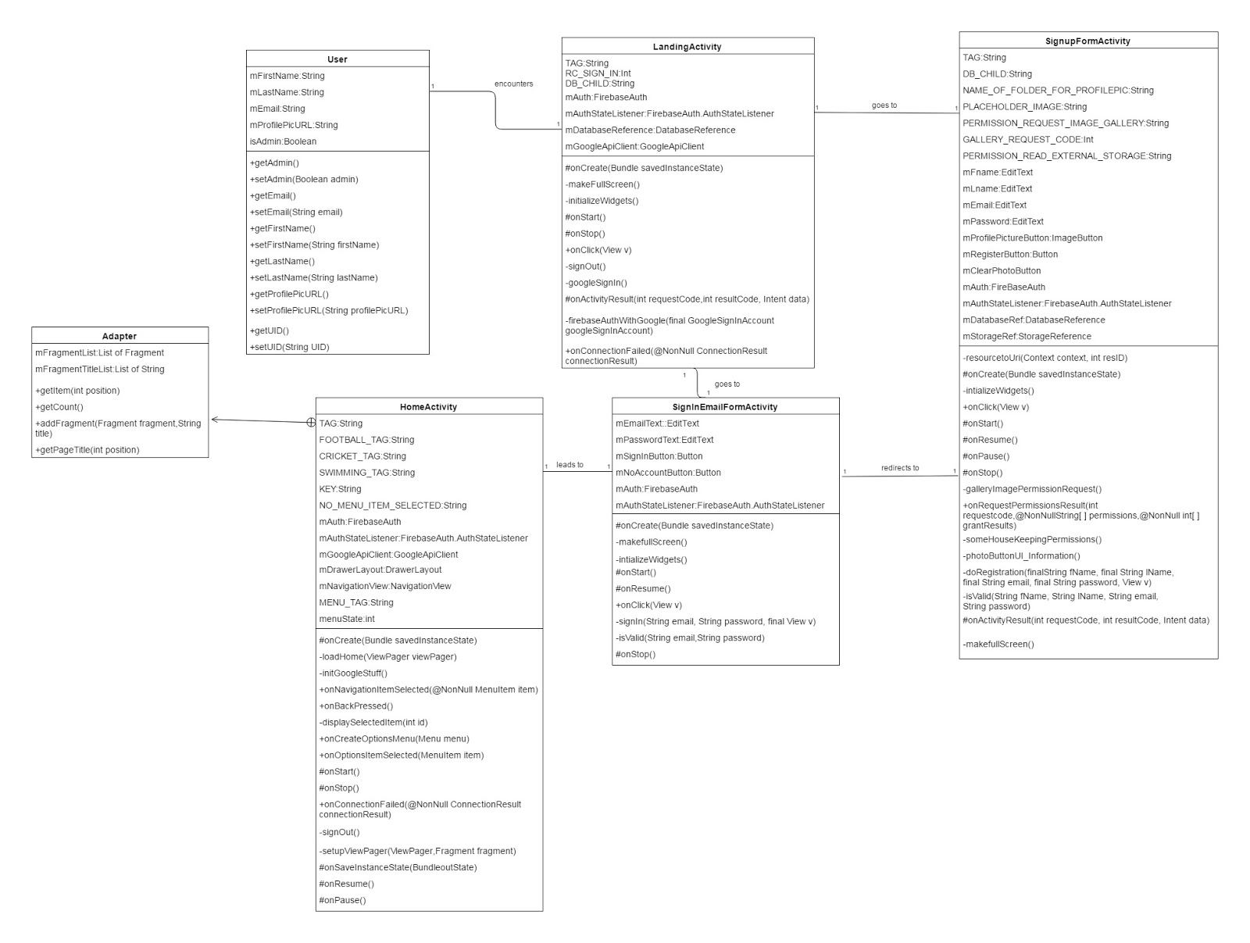

**Segment 2**

This following images illustrate how the HomeActivity, FeaturedFragment, FeaturedCategoryFragment, RecycleViewAdapter, ArticleViewHolder and Article classes interact with each other in other to fill the general Featured page and a selected category’s featured page with appropriate articles.

Fig 1

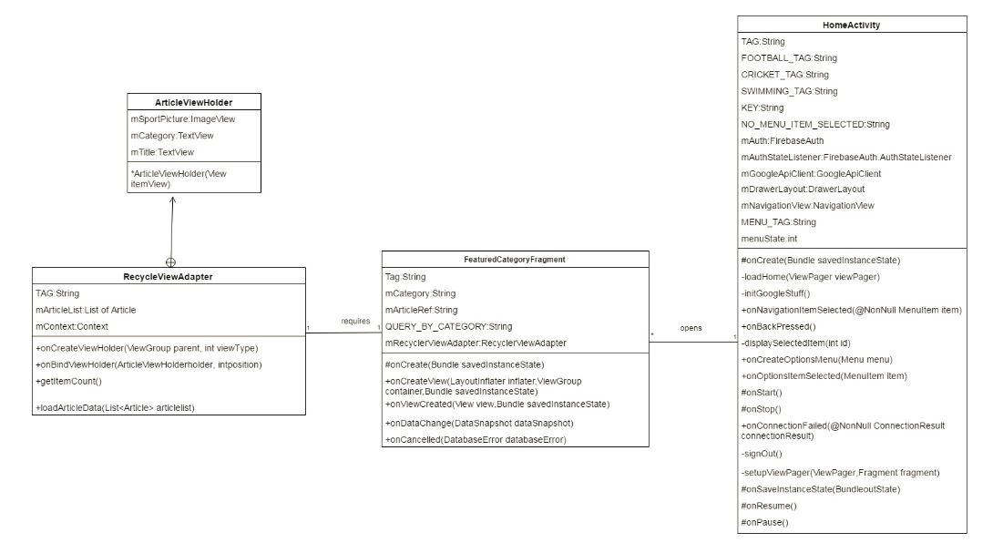

Fig 2

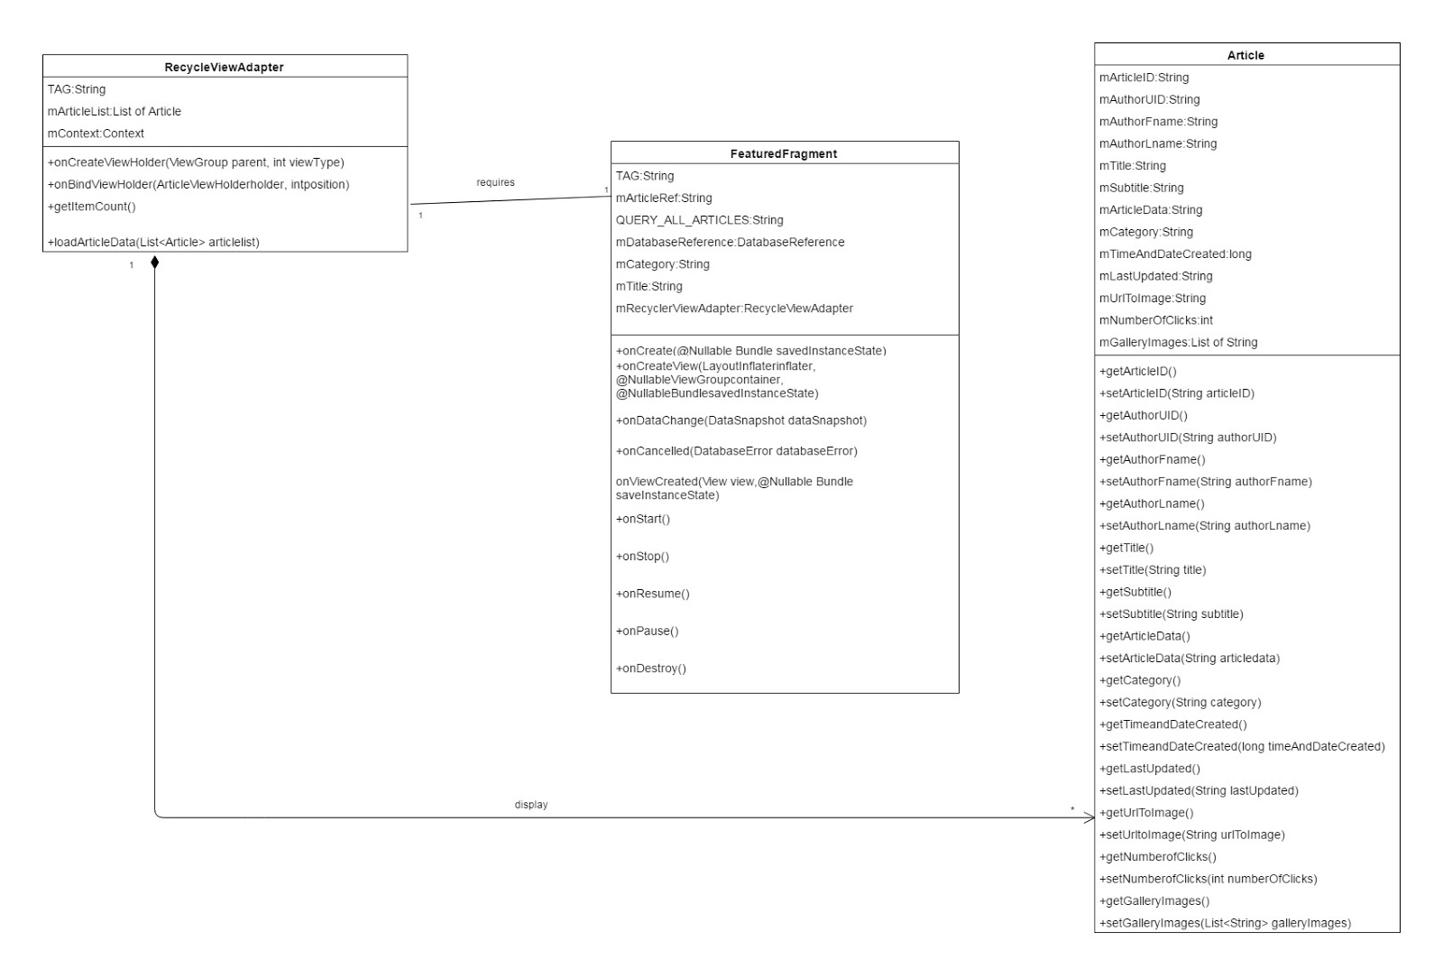

**Segment 3**

This following images illustrate how the HomeActivity, LatestFragment,LatestCategoryFragment ListViewAdapter ,ListViewHolder and Article classes interact with each other in other to fill the general Latest page and a selected category’s Latest page with appropriate articles.

Fig 1

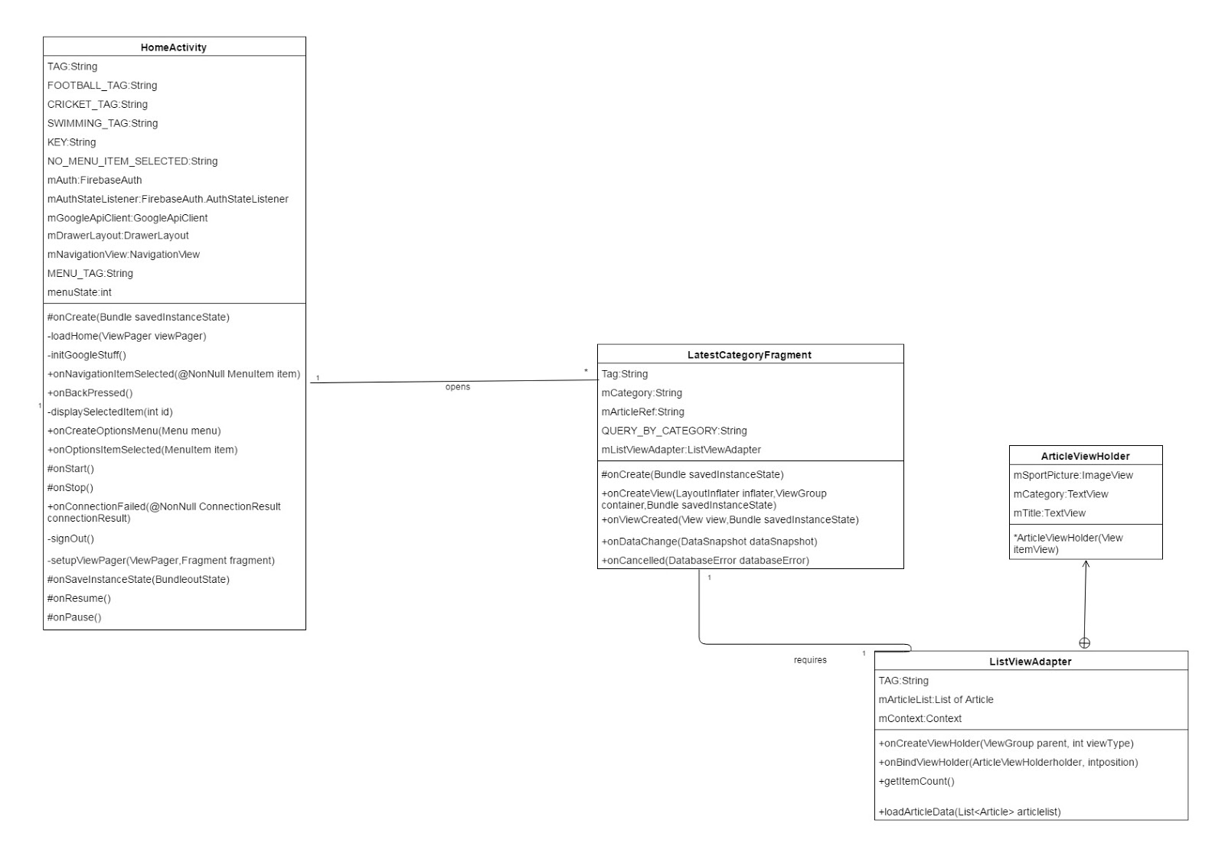

Fig 2

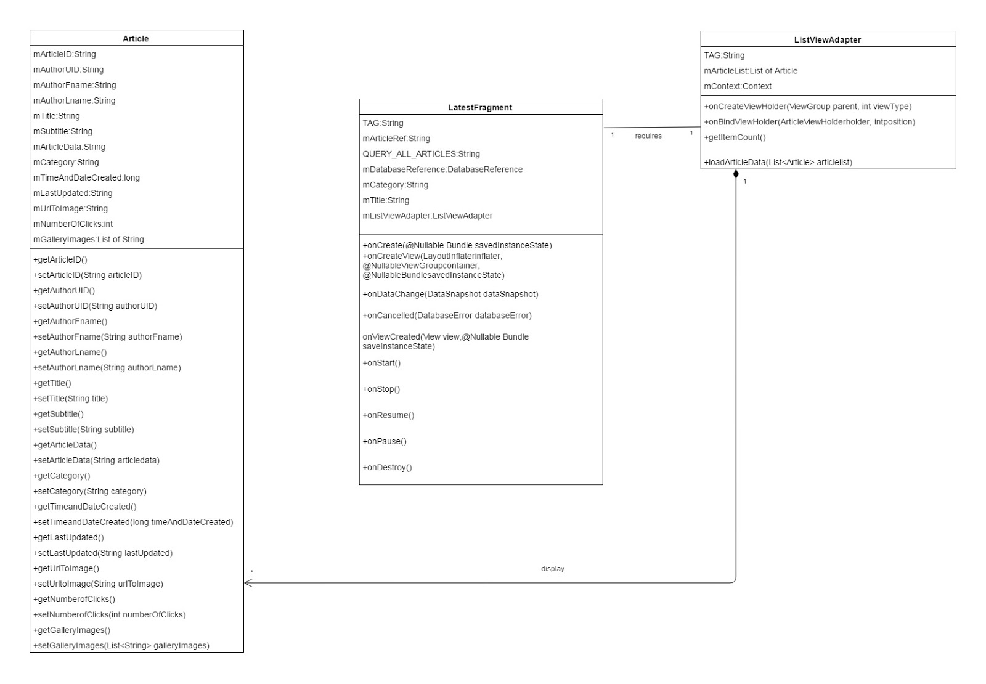

**Segment 4**

The figure below shows the segment of the class diagram with the HomeActivity,FeaturedFragment and the LatestFragment classes and how they interact. These two ‘fragment’ classes refer to the general Latest and Featured pages within the site and do not refer to any specific sport category.

## **6th.jpg**

## **Appendix 7**

Web application component diagram

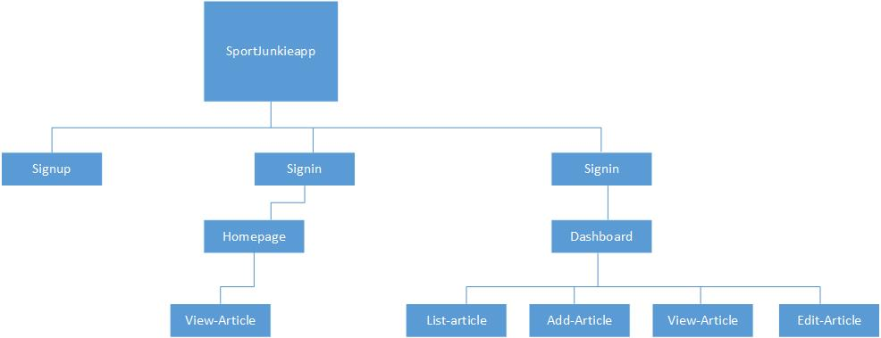

## **Appendix 8 – Usability Testing User Questionnaire**

The following questions are designed to obtain feedback from you after having used our mobile

application.

Instructions: Please answer the following questions by circling the appropriate number

1 - Strongly Disagree

2 - Disagree

3 - Neutral

4 - Agree

5 - Strongly Agree

**Match between System and the Real world**

1. Is the information presented in a simple, natural and logical order?

1 2 3 4 5

2. Are the words, phrases and concepts in the app familiar to you?

1 2 3 4 5

**User Control and Freedom**

3. Are there any navigational tools/facilities to return to the homepage?

1 2 3 4 5

4. Is the menu available and functional on every page you have visited?

1 2 3 4 5

5. Can users easily undo and/or redo actions on the application?

1 2 3 4 5

**Flexibility and Efficiency of use**

6. Does the application allow for a wide range of user expertise?

1 2 3 4 5

**Aesthetic and Minimalistic Design**

7. Are the application fonts easy to read?

1 2 3 4 5

8. Is the application free from irrelevant, unnecessary and distracting information?

1 2 3 4 5

9. Are the icons clear and buttons labelled and is the use of graphic controls obvious?

1 2 3 4 5

10. Is the application easy to remember how to use?

1 2 3 4 5

**Structure of information**

11. Are related pieces of information clustered together?

1 2 3 4 5

12. Are the application’s descriptions accurate and understandable?

1 2 3 4 5

**Navigation**

13. Is navigational feedback provided? (Are you aware of your previous and current position at all times? are you aware of your navigational options?

1 2 3 4 5

**Recognition rather than recall**

14. Are icons easily indicated/known?

1 2 3 4 5

**Performance**

15. Were there any noticeable problems with the application after prolonged use? If yes please describe:

__________________________________________________________________________________________________________________________________________________________________________